Practical 6

Aim: Import the Datawarehouse data in Microsoft Excel and create the Pivot table and Pivot Chart.

Theory:
Explain Pivot Table and Pivot Charts in detail.
Case 1:
Dataset: SalesData
Questions:
- Find sum of units sold by each sales representative.
Steps:
Insert->pivot table
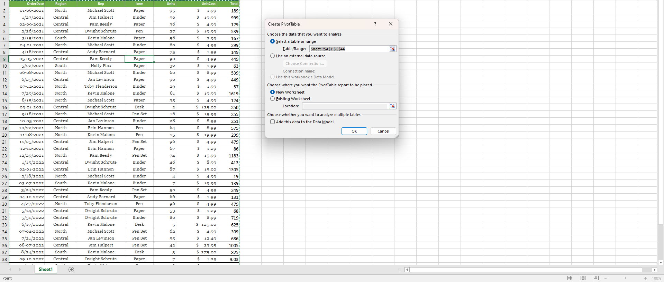
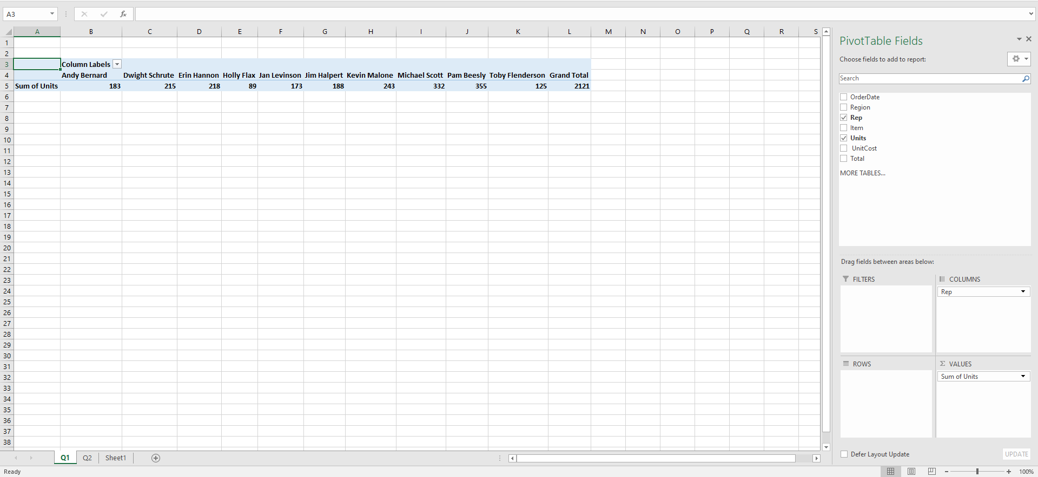
- Insert Rep into Columns.
- Insert Units into Values.
- Done.

- Find Region-wise sum of units sold by each sales representative for each item.
Steps: Adjusting Rows and Columns: Customizing pivot tables for better data visualization.

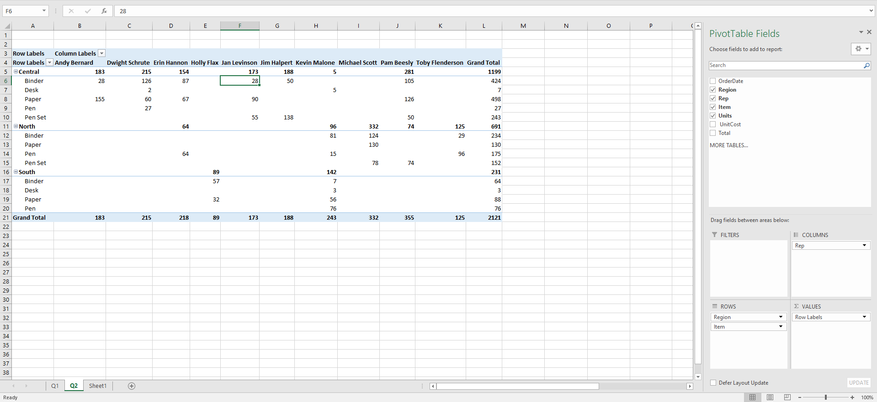
- Drag Region in Rows.
- Drag Rep in Columns
- Drag Items in Rows
- Drag Units in Values
- Done.

- Sort number of units sold by each sales representative in descending order and find sales representative who sold highest units of which item.
Steps: Sorting in Pivot Tables: Techniques for efficient data organization.
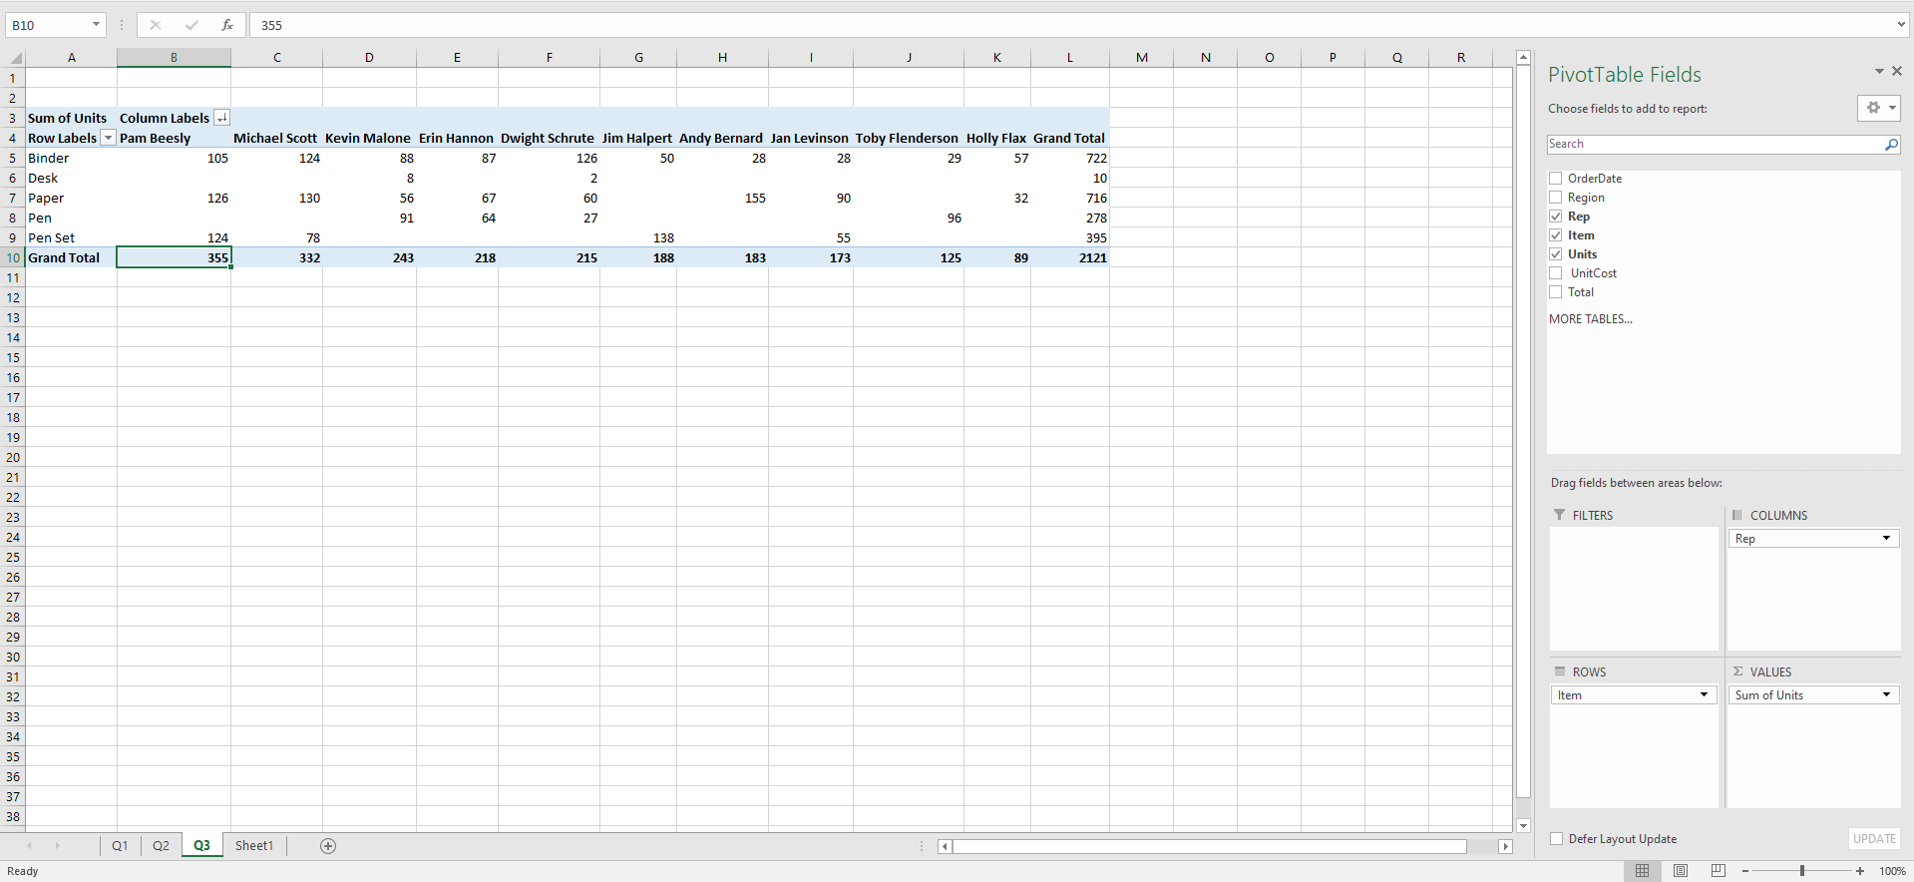
- Drag Items into Rows.
- Drag Reps into Columns.
- Drag Units into Items.
- Right Click on Grand Total Row -> Click on Sort -> Click Largest to Smallest/
- Done.

- Find number of units sold by each sales representative of all items in central and south region using filter concept.
Steps: Filtering Pivot Tables: Learn to focus on the data that matters most.
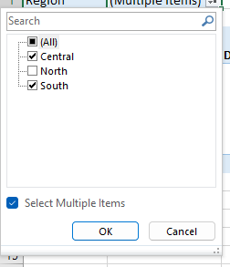
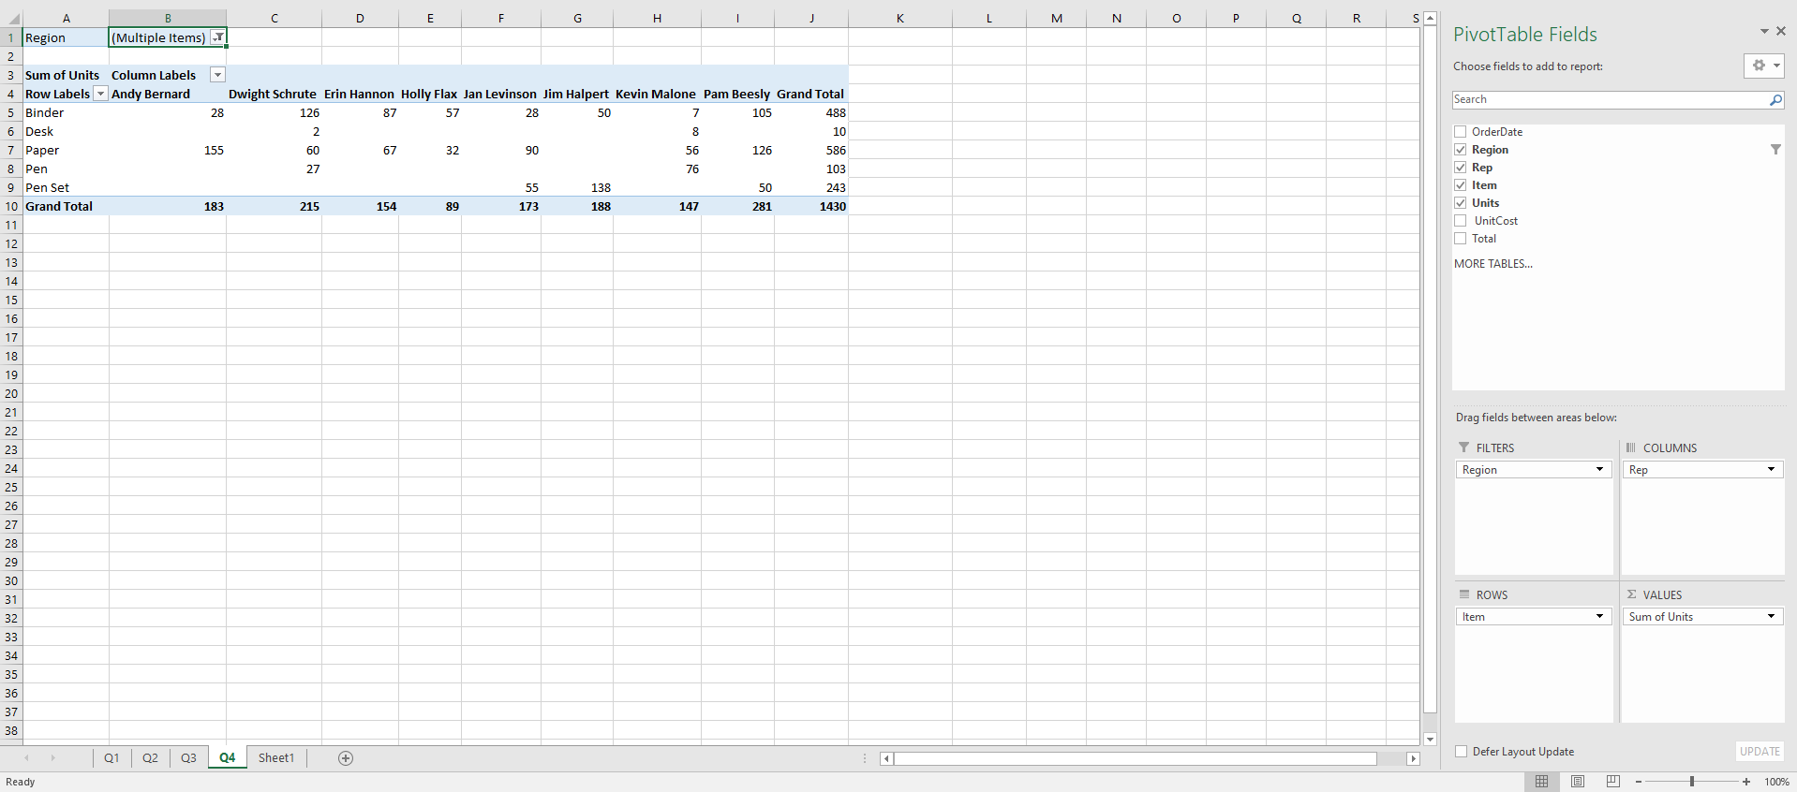
- Drag Region in Filters.
- Drag Rep in Columns
- Drag Items in Rows
- Drag Units in Values
- Done.
The output will show the sum of units sold by each representative for each item for the Regions Central and South ONLY.
- Create report of each sales representative in different sheets showing item wise, total sales made by individual sales person.

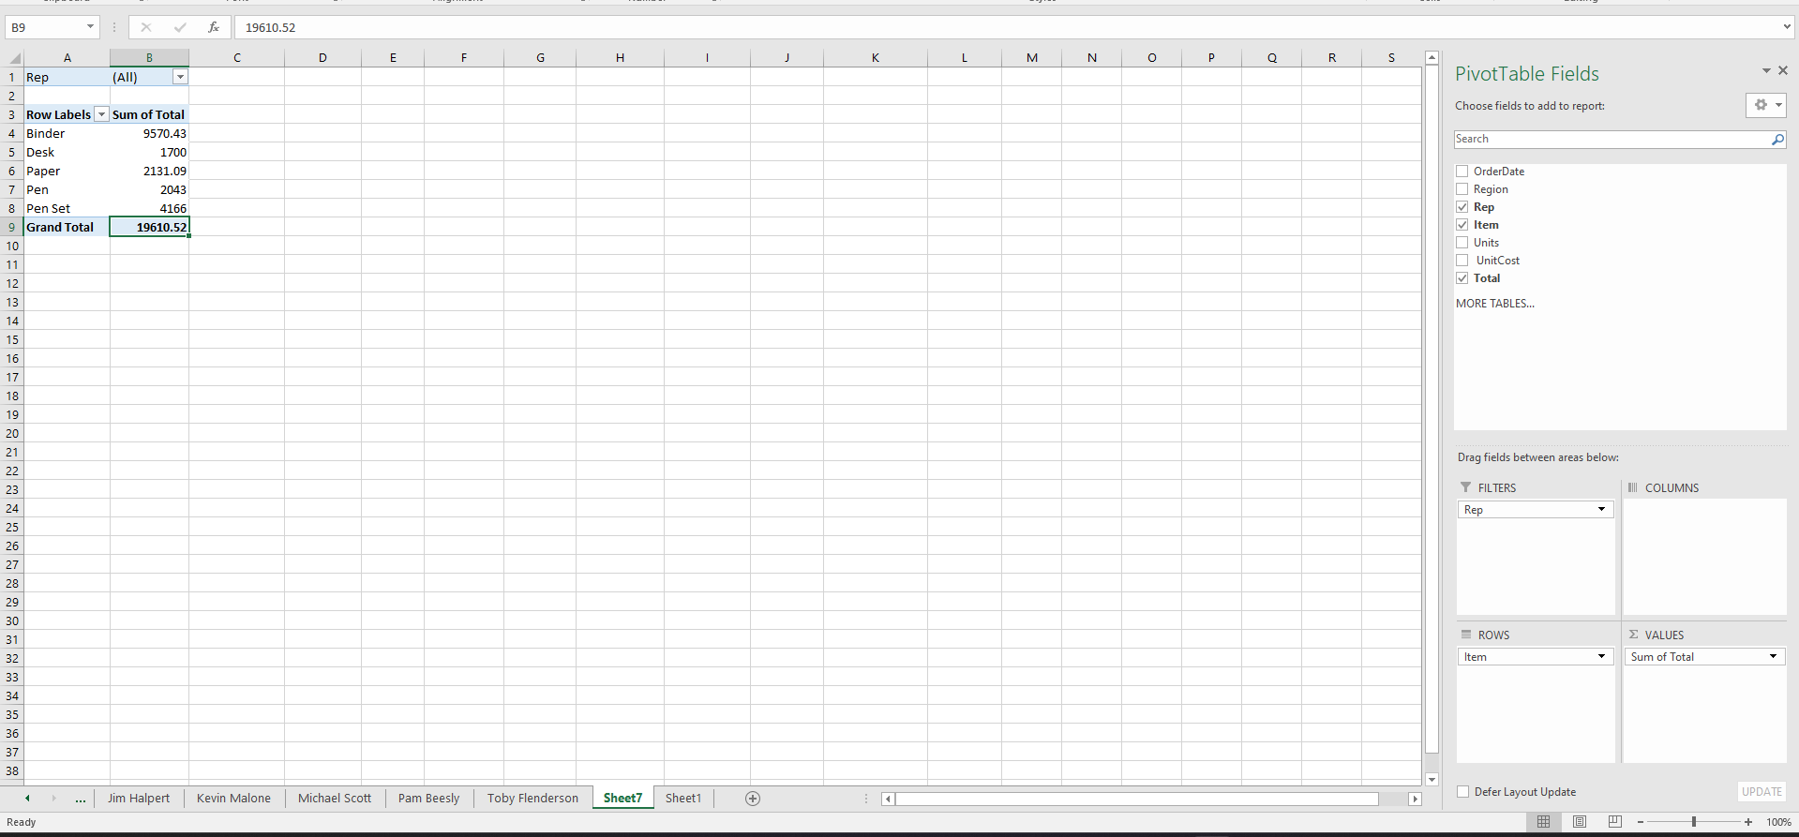

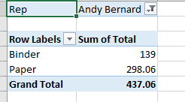

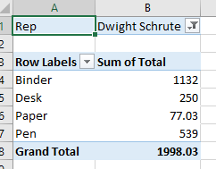

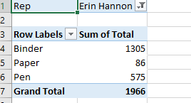

- Insert Rep into Filters.
- Insert Items into Rows.
- Into Total into Values.
- Click on Table -> Click Analyze from Toolbar -> Show Report Filter Pages -> Select Rep -> OK.
- Done.

- Create a report showing individual units sold by sales representative for item paper.
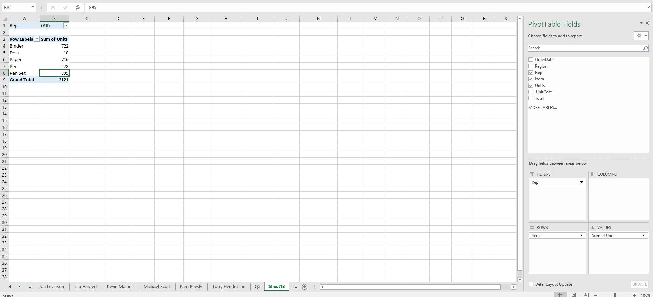

- Insert Rep into Filters
- Insert Item into Rows.
- Units into Values.
- Double Click on Sum of Units value besides Paper
- Done.
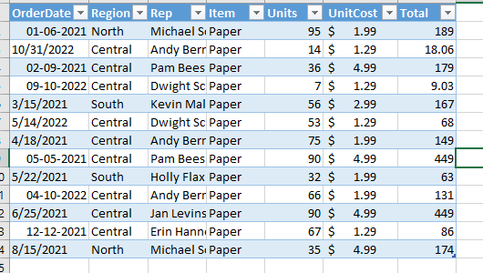

- Find out percentage of sales out of total sales made by each item.
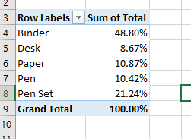

- Insert Total into Values.
- Insert Items into Rows.
- Right Click on Sum of Total any Value -> Show Values as -> % of Column Total.
- Done.
- Show the item wise total sales, in horizontal bar chart format using conditional formatting.

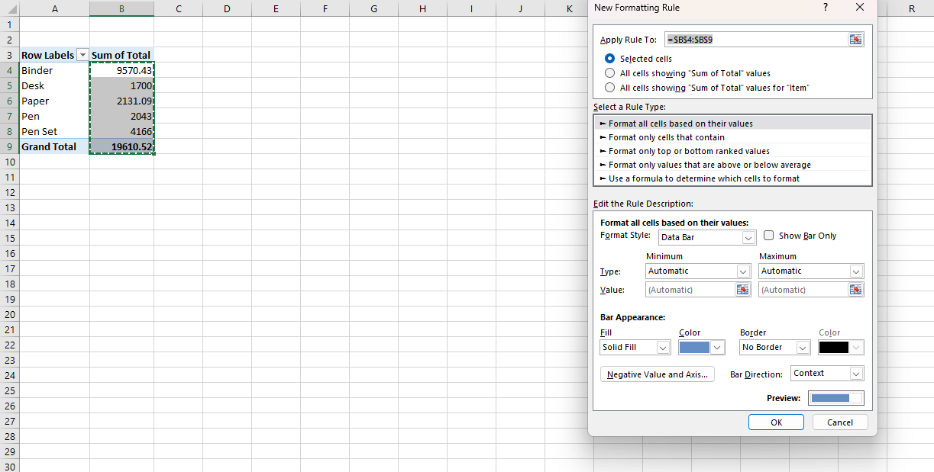

- Insert Items into Rows.
- Insert Total into Values.
- Click Home on Toolbar -> Conditional Formatting -> Hover Data Bars -> Click More Rules -> Click Show Bar Only Then Border Solid Border Select Color -> Then OK.
- Done.

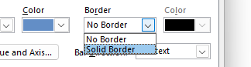
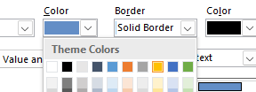


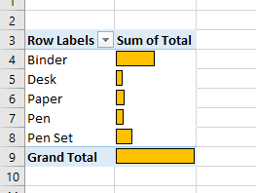

- Draw pie chart showing sum of total sales, item wise.

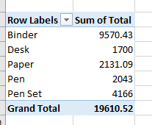
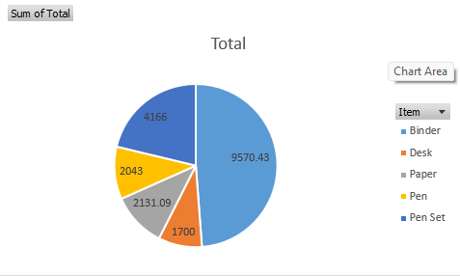

- Draw pie chart for individual sales representative showing his total sales. Give different colour for each pie chart for each Sales representative. Add title of pie chart to showing sales representative name.

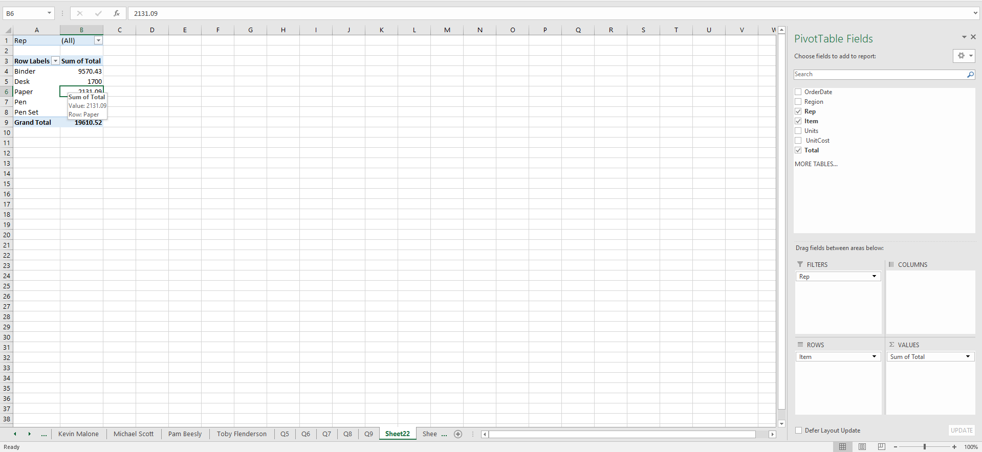

- Insert Items into Rows.
- Insert Total into Values.
- Insert Rep into Filters.
- Click on Insert on Toolbar -> 3D Pie Chart
- Add Labels
- Done.
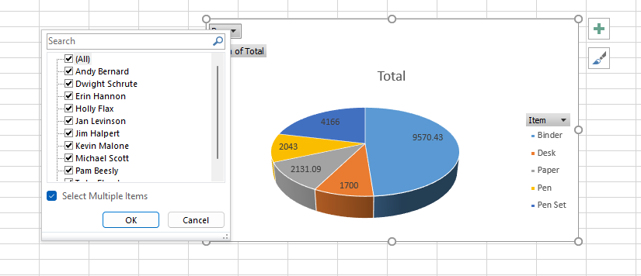

Case 2:
Dataset: OrderData
Questions:
- Find country wise, product wise total order amount. Add filter for category.
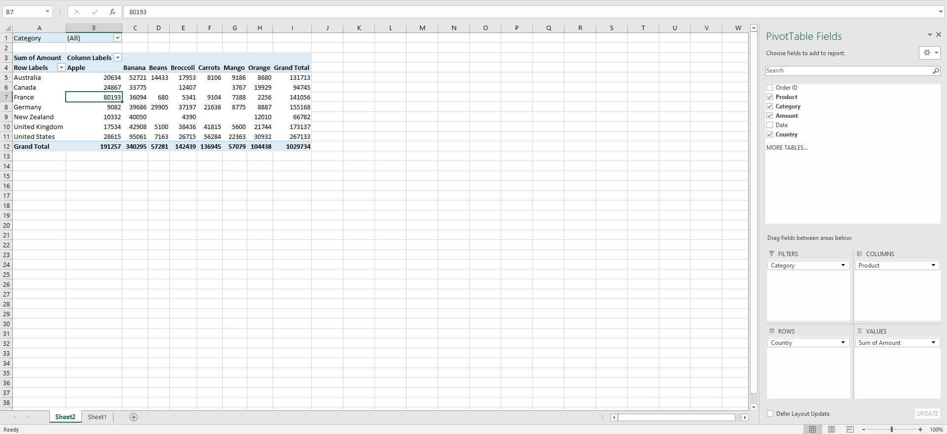

- Create report of each country in different sheets showing category wise, product wise order amount.
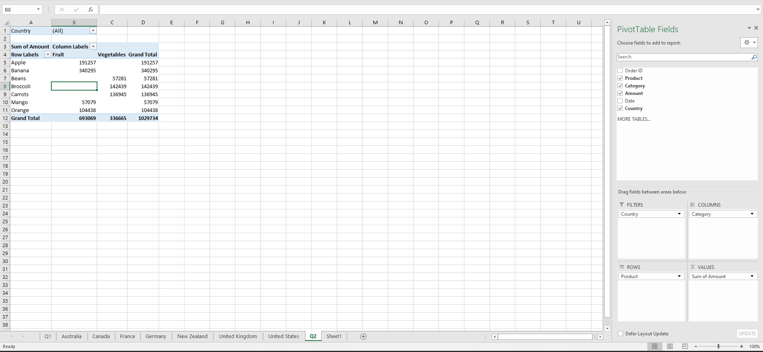
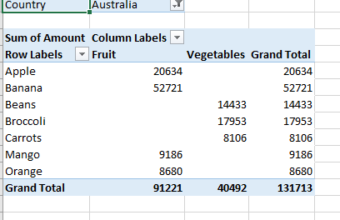
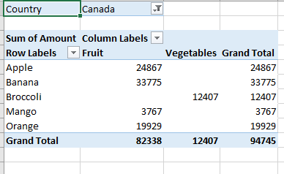
- Create a report showing individual order amount per country for product “Broccoli”.
- Show the category wise order amount, in horizontal bar chart format using conditional formatting.
- Draw horizontal bar chart showing sum of total amount, product wise and then category wise.

